8.12: The change in the ball’s momentum in the x-direction (taken to be positive to the right) is so the x-component of the average force is

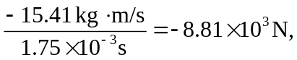
and the y-component of the force is

